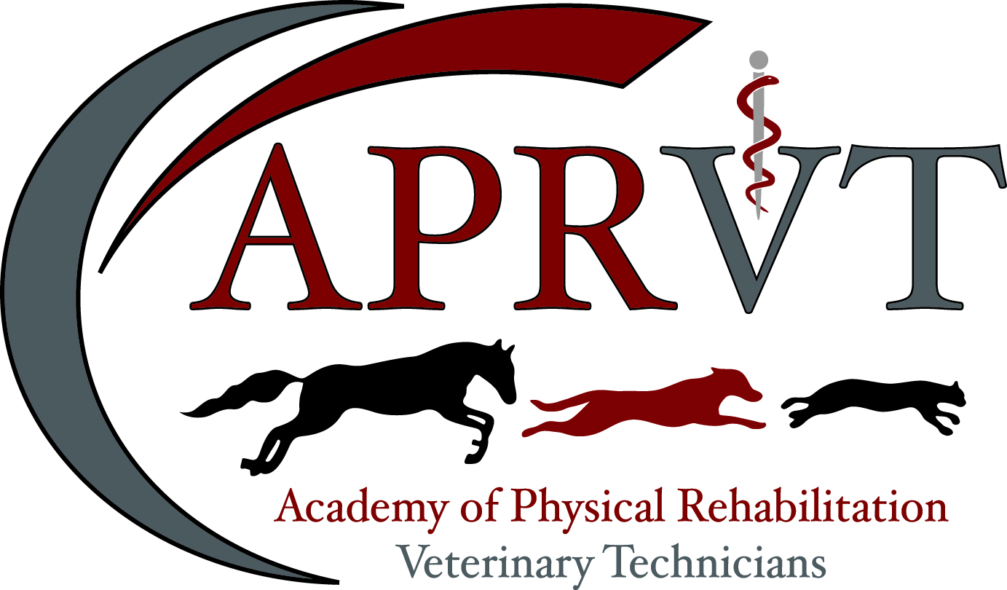

2018 Mentor Packet

Mentor Packet Table of Contents
Introduction | 3
Pre-Application Check list | 4
Regulatory and Practice Knowledge | 5
Applicant Request Letter | 6
Questions to ask before deciding to be a mentor | 7
How to evaluate a potential applicant as a possible mentee | 8
Key Points for Mentors | 9
Applicant/Mentor Agreement | 10
Veterinarian Mentor Agreement Form | 11
Waiver, Release and Indemnity Agreement | 12

Mentorship Packet Introduction

Each VTS candidate should be supervised by a veterinarian who is certified in veterinary rehabilitation or is a diplomate of Veterinary Sports Medicine and Rehabilitation (DACVSMR). This “mentor” should be in the same locality as the candidate and should be able to communicate at a minimum by video conferencing. Non-VTS CVT’s and Physical Therapists with rehabilitation credentialing will not be accepted for mentorship.

The decision to become a mentor to a colleague is an important step in a successful APRVT training program and, ultimately, a successful completion of this veterinary technician specialty. The purpose of the mentor is to guide and evaluate the mentee through the processes of their training program, the submission of their credential materials, and the examination preparation.

In addition to the mentor providing veterinary physical rehabilitation knowledge and expertise, mentorship will require time for evaluation of case treatments and submission materials. Mentors
should be familiar with the current APRVT program requirements. Each mentor needs to obtain a copy of the credentials packet, detailing the program requirements and APRVT-approved forms, to ensure that they are participating using the same materials as the applicant. Mentors are encouraged to outline a plan to accomplish the credentialing process and communicate the structure to the applicant. Both the mentor and mentee should agree upon the planned outline.

All mentors must provide verification of their credentials, level of experience and brief description of how they will ensure the applicant will achieve their APRVT VTS requirements. The VTS applicant is responsible for distributing the Mentor Agreement/Request Form and all other requested documents provided in the mentor packet. Completed Documents may be sent to by uploading documents to an online Cloud Drop Box then send a link to the Credentialing and Case Review chairperson. Applicants are responsible for their own Drop Box accounts.

On behalf of the Academy of Physical Rehabilitation Veterinary Technicians, I would like to thank you for supporting your technician through the application process. If you have any questions, please do not hesitate to contact the Credentialing and Case Review chair.

Sincerely,

Kristen Hagler BS (An.Phys.) RVT CCRP CVPP OACM CBW
APRVT President and CEO, Credentialing and Case Review Chair
NAVTA CVTS APRVT Liaison
Goldengaitk9@GMail.com

APRVT Pre-Application Checklist

One year prior to a scheduled examination date, all APRVT training program applicants and their mentors must together submit several required documents to the Credentialing and Case Review chair of the APRVT:

A completed application packet includes ALL required forms and documents in an electronic format. Because sending large file formats via electronic mail has limitations, please upload to an online Cloud Drop Box then send a link to the Credentialing and Case Review chairperson. Applicants are responsible for their own Drop Box accounts.

To be submitted by 11:59:59 January 1st of the year prior to application deadline

One brief letter of intent addressed to the APRVT Credentialing and Case Review Committee Chair that describes who you are and why you are interested in becoming an APRVT member
Filename Instructions: LASTNAME_FIRSTNAME_LETTEROFINTENT_APRVT_YEAR

Two (2) letters of recommendation. (Sent separately by the letter writers). If sent via postmarked mail please notify the Academy via electronic mail, otherwise please send via electronic mail
Filename Instructions: LASTNAME_FIRSTNAME_RECCLETTER_APRVT_YEAR

Please refer to the website www.aprvt.com for required forms and details. Once a letter of intent is received, the credentialing and case review chairperson will contact the applicant with an Applicant Registration Number (ARN). Complete Bylaws, Constitution and Code of Ethics for the APRVT are available at the web URL http://www.aprvt.com/

Applicants may then start completing the application and mentor packet upon receipt of a ARN.

Academy of Physical Rehabilitation Veterinary Technicians
Mentorship Packet - Regulatory and Practice Knowledge

The VTS (Physical Rehabilitation) must have an intimate understanding of regulatory guidelines and principles within their individual state or provincial veterinary practice acts as they relate to animal physical rehabilitation. Where a rehabilitation veterinarian is not able to directly supervise the VTS (Physical Rehabilitation), a state licensed veterinarian must supervise veterinary physical rehabilitation patients. The VTS (Physical Rehabilitation) must also be able to work collaboratively with colleagues outside of the veterinary profession. A mentor must verify that potential applicants have a thorough understanding of the information listed in the table below. At this time a Physical Therapist or VTS in any specialty will not be accepted to attest to the knowledge listed below.

 | Description | Date | Evaluator Initials
1 | Be able to describe the role of the credentialed veterinary technician including definitions of respective practice acts within the applicant’s current state
2 | Be able to explain the role of collegial relationships in veterinary physical rehabilitation (Chiropractor, Physical Therapist, Acupuncturist, Massage Therapist)
3 | Be able to describe the Model Practice Act of Animal Physical Rehabilitation and Complementary/Alternative Medicine (CAVM) as defined by the American Veterinary Medical Association (AVMA)
4 | Be able to describe the ideal practice model as written by the American Association of Rehabilitation Veterinarians (AARV)
5 | Be able to describe the concept and importance of the Veterinary-Client-Patient relationship during physical rehabilitation.
6 | Be able to describe the role of the referring veterinarian and methods of referral including the importance of communication in a timely manner (following the AVMA Principles of Veterinary Medical Ethics)

Mentorship Packet - Applicant Request Letter

To be submitted to the mentor by the mentee.

Dear Supervising Veterinarian,

This letter has been presented to you by a credentialed veterinary technician currently employed at your facility, who has an interest in pursuing membership in the Academy of Physical Rehabilitation Veterinary Technicians (APRVT). In order to achieve this objective, your technician will complete a two-step process of submitting an application packet for approval by the APRVT credentialing committee and sitting for a comprehensive examination. Successful completion of both steps will earn your technician the title of Veterinary Technician Specialist in
Physical Rehabilitation. A technician with VTS (Physical Rehabilitation) certification demonstrates superior knowledge in the care and management of veterinary physical rehabilitation cases while promoting patient safety, consumer protection and professionalism.

The application process is especially time consuming and your technician will need your support and guidance throughout the process. I recommend that you read the entire application packet to become familiar with the areas in which your technician will require your assistance. Listed below are some areas of the application that are particularly important as well as some suggestions and guidelines to assist you in helping your technician prepare an application for submission. All cases contained in the case log must be performed within the year prior to the application deadline due March 31st of each calendar year.

All cases must be performed at the facility where the technician is employed or while under the supervision of the employer at a different location (i.e., your clinic performs physical rehabilitation services at a different location but you and your technician are still in charge of the case and perform the services).

Allow your technician to assist in developing a rehabilitative plan from start to finish. The technician should be able to anticipate the needs of the veterinarian performing a procedure, including equipment, therapeutic exercise technique, postoperative care when necessary, bandages, diagnostics, etc. that is specific for each case and discuss with you why they selected each modality, piece of equipment, exercise, client education, etc.

The APRVT requires that a licensed veterinarian is experienced in rehabilitation or is a board certified veterinary specialist attest to the technician’s ability to master the required percentage of skills on the APRVT Advanced Skills Form. In those sections where a VTS may attest to a subset of skills within their specialty, applicants must contact the credentialing chair prior to an evaluator attesting to a skill.

Mentorship Packet - Questions to ask before deciding to be a mentor

- Do I enjoy working with others and sharing my veterinary physical rehabilitation knowledge and skills?
- Do I have the space to provide a work area for a mentee to study and perform physical rehabilitation skills?
- Do I have time to evaluate the clinical performance of a mentee and the paperwork associated with it? Yearly applicant submissions of logs and other documents are required to be evaluated and signed by the mentor. 40 minimum specified required cases must be formally reviewed during the training program. Five case reports, written by the applicant, must be reviewed and evaluated by the mentor prior to submission to the Credentials Committee.
- Is the mentee legally qualified to perform physical rehabilitation in my hospital and will the practice owner allow it?
- Can I maintain an objective professional relationship with an individual who may also be a friend? Honest evaluation and constructive criticism of work performance and materials are required for the advancement of high standards in veterinary physical rehabilitation. A mentor must to be prepared to address program or mentee inadequacies and terminate a program if necessary.
- Am I aware of my strengths and weaknesses in the training, experience and caseload of all major aspects of physical rehabilitation? Can the outline for mentorship accommodate these strengths and weaknesses by utilizing other APRVT colleagues or outside rotations, if necessary?
- How well do you know each other? Are you familiar with the work of the applicant? Have you worked together at conferences or on cases before?
- Is the applicant aware of the scope of the commitment involved in starting and completing the training period, credential application process and for the certifying examination preparation?
- Is the applicant preparing or participating in other major professional or personal accomplishments?

Mentorship Packet - How to evaluate a potential applicant as a possible mentee

The requirements for an APRVT credentialing program are based on a 2-year time frame. Therefore, a successful and rewarding mentor-mentee relationship requires planning and agreement prior to the start. It is important to know as much as possible about the applicant, through review of his or her curriculum vitae, evaluation of the applicant’s current level of physical rehabilitation skills and discussion of the applicant’s desire and commitment toward advanced veterinary physical rehabilitation. Undertaking a veterinary physical rehabilitation training program requires a great amount of involvement, time and money. The applicant must be familiar with and agree to all the basic program requirements, the protocol of the APRVT training program and prerequisites for admission to the certifying examination. The mentee also must be aware of other time and financial commitments including (but not limited to):

- An increase in his or her advanced physical rehabilitation caseload
- An ability and willingness to keep detailed records and logs and devote time to the other associated training program documentation
- Travel to CE programs
- Training program dues to the APRVT
- Preparation of admission materials and associated fees for commencing the training program and the credential and examination applications
- The applicant’s willingness and ability to take time off from the clinical case load to study and practice for the certifying examination

The mentor should communicate to the applicant the structure of the mentor program and also outline the review process. Discussion should also include information regarding mentor guidance and mentee evaluation. Although the mentor and applicant may be friends, one purpose of the mentor is to critique the applicant’s work and submissions. The mentee should not take remarks personally. A mentor or mentee may recommend a provisional working period to see how the mentor/mentee relationship is going to work

KEY POINTS for Mentors

- Look over the skills list completely and only sign off on a skill if you feel confident that your technician meets the definition of mastery.
- All signed skills must be demonstrated in the case logs.
- Assist your technician in acquiring new skills for the application process.
- Send your technician to at least one national meeting a year to give them ample exposure to the most current information related to physical rehabilitation and allow them to accumulate continuing education credits.

On behalf of the Academy of Physical Rehabilitation Veterinary Technicians, I would like to thank you for supporting your technician through the application process. If you have any questions please do not hesitate to contact me.

Sincerely,

Kristen Hagler BS (An.Phys.) RVT CCRP CVPP OACM CBW
APRV T President and CEO
NAVTA APRVT (Proposed) Liaison
Goldengaitk9@GMail.com
www.aprvt.com

Mentorship Packet – Applicant/Mentor Agreement

I, ____________________________________, do hereby contract with
_____________________________________ to be my veterinary physical rehabilitation mentor.

I will provide my mentor with an outline detailing how I intend to accomplish my training program. My mentor must then approve this outline. Once the training methods are agreed upon, my mentor must sign this proposal and I will submit it to the APRVT Board of Directors for further approval.

We will be in contact ________ (applicant insert frequency) times per year via phone, email, letter, fax, and/or in person to review my progress.

I will submit at least one half of my case logs and case reports to my mentor by __________________ for review.

The remainder of my credentials packet will be submitted for review by my mentor by ____________

Applicant |  | Mentor
(Signature) |  | (Signature)

Printed Name |  | Printed Name

Mentor Contact Information: (Please Print clearly- this is primary means of contact)
Street Address
State/Province
Zip Code
Phone
Email Address

Mentorship Packet - Veterinarian Mentor Agreement Form

The APRVT requires a licensed veterinarian or a VTS who has mastered the skill attest to your ability to perform the task. Your testifier must sign at the bottom of the form to validate their initials throughout the form. Mastery is defined as being able to perform the task safely, with a high degree of success, and without being coached or prompted. Mastery requires having performed the task in a wide variety of patients and situations. The applicant must demonstrate mastery of 80% of the skills on this form. The skills you have mastered must be demonstrated in your case logs and case reports.

The APRVT understands that some of the skills may be difficult to demonstrate in a typical case log summary. Once you have documented at least 40 valid cases in your case log you may utilize any remaining case log entries for the sole purpose of documenting these skills (i.e., “Dr. Roberts verified my ability to use Electrical Stimulation in the management of post-operative surgical IVDD”, “Dr. Smith verified that I correctly identified orthopedic lameness and properly documented this in the medical record.” “Dr. Jones witnessed me safely and properly handling patients requiring additional assistance during hydrotherapy (underwater to swimming).” “Drs. Daniels and Murphy verified my client education communication when discussing a home therapeutic exercise program and ability to properly instruct on patient pain assessment.”)

Please do not exceed 60 case log entries. Additional case log entries are encouraged in the event an individual case log is not acceptable for submission.

If a skill was mastered at a prior place of employment listed in your employment history, it must be validated by the veterinarian associated with the prior employment in the form of a signature on the skills list form or by a letter stating such.

Applicant |  | Mentor
(Signature) |  | (Signature)

Printed Name |  | Printed Name

Mentor Contact Information: (Please Print clearly- this is primary means of contact)
Street Address
State/Province
Zip Code
Phone
Email Address

Mentorship Packet - Waiver, Release and Indemnity Agreement

This form must be signed and dated and included in your applicant packet. Electronic submission via Portable Document File (.PDF) is accepted as part of the submission packet.

I hereby submit my credentials to the Academy of Physical Rehabilitation Veterinary Technicians (APRVT) for consideration for examination in accordance with its rules and enclose the required application fee. I agree that prior to or subsequent to my examination; the APRVT Executive Board may investigate my standing as a veterinary technician, including my reputation for complying with the standards of ethics of the profession. I understand and agree that the application fee shall be nonrefundable.

I agree to abide by the decisions of the Executive Board and thereby voluntarily release, discharge, waive and relinquish any and all actions or causes of actions against the Academy of Physical Rehabilitation Veterinary Technicians and each and all of its members, officers, examiners and assigns from and against any liability whatsoever in respect of any decisions or acts that they may make in connection with this application, the examination, the grades on such examinations and/or the granting or issuance, or failure thereof, of any certificate, except as specifically provided by the Constitution and Bylaws of this organization. I agree to exempt and relieve, defend and indemnify, and hold harmless the Academy of Physical Rehabilitation Veterinary Technicians, and each and all of its members, officers, examiners and assigns against any and all claims, demands and/or proceedings, including court costs and attorney’s fees, brought by or prosecuted for my benefit, extended to all claims of every kind and nature whatsoever whether known or unknown at this time. I further agree that any certificate, which may be granted and issued to me, shall be and remain the property of the Academy of Physical Rehabilitation Veterinary Technicians.

I understand that as part of the application submitted herewith I am being asked to suggest issues, questions and ideas which the Academy of Physical Rehabilitation Veterinary Technicians can include in future examinations. I hereby assign to the Academy of Physical Rehabilitation Veterinary Technicians all right, title and interest in and to any and all such issues, questions and ideas which I may submit to Academy of Physical Rehabilitation Veterinary Technicians now or in the future.

I certify that all information provided by me on the application submitted herewith is true and correct. I acknowledge that I have read, understand and agree to abide by the terms and conditions stated above.

Full name and title: ____________________________________________________________

Date: ________________________________________

